RAJALAKSHMI INSTITUTE OF TECHNOLOGY
(An Autonomous Institution, Affiliated to Anna University, Chennai)


DEPARTMENT OF ARTIFICIAL INTELLIGENCE AND DATA SCIENCE ACADEMIC YEAR 2025 - 2026
SEMESTER IV

AD23411 – DATA ANALYTICS LABORATORY MINI PROJECT REPORT

REGISTER NUMBER
NAME
PROJECT TITLE
DATE OF SUBMISSION
FACULTY IN-CHARGE

Signature of Faculty In-charge Signature of HoD

Internal Examiner External Examiner

INTRODUCTION

In the modern digital world, Data Analytics plays a crucial role in extracting meaningful insights from
large volumes of data. It is widely used across various domains such as healthcare, finance, business,
and technology to support decision-making and predict future trends. In the financial sector, data
analytics is especially important for understanding stock market behavior, as it helps analyze complex
and continuously changing market data.

The stock market generates a vast amount of time-based data, where prices fluctuate due to factors such
as economic conditions, company performance, investor sentiment, and global events. Analyzing this
data manually is difficult, which makes analytical techniques essential. One of the most effective
approaches used in this domain is Time Series Analysis, which focuses on analyzing data points
collected over time to identify patterns such as trends, seasonality, and irregular variations.

This project focuses on applying data analytics techniques to study stock market trends using historical
data. By utilizing tools and libraries in Python, the collected data is processed and analyzed to uncover
hidden patterns. Techniques such as moving averages are used to smooth fluctuations and highlight
overall trends, while autocorrelation analysis helps in understanding the relationship between past and
present stock prices. Visualization methods are also used to present the data in a clear and interpretable
format.

The main aim of this project is to demonstrate the practical application of data analytics in the financial
domain. By analyzing stock market trends, the project provides insights into market behavior and lays
the foundation for further predictive analysis and informed investment decisions

PROBLEM STATEMENT

The stock market generates a large volume of time-dependent data that is highly dynamic and complex in nature. Due to continuous fluctuations influenced by economic conditions, company performance, and global events, it becomes difficult to manually analyze and identify meaningful patterns in stock prices. This creates a challenge for understanding market trends and making informed decisions.

Although raw stock data is easily available, extracting useful insights such as trends, relationships, and future behavior requires proper analytical techniques. Without applying systematic methods, it is hard to interpret whether the market is following an upward trend, downward trend, or showing random variations.

To address this problem, this project aims to utilize Data Analytics techniques, particularly Time Series Analysis, to analyze historical stock price data. The project focuses on identifying trends, studying patterns using moving averages, and examining relationships through autocorrelation, along with visualizing the results for better understanding

GOAL

The primary goal of this project is to utilize Data Analytics techniques to systematically analyze stock market data and extract meaningful insights from large volumes of time-based information. The project aims to study the behavior of stock prices over a period of time using Time Series Analysis, which helps in identifying patterns such as trends, fluctuations, and dependencies within the data.

Another important goal is to simplify complex stock data by applying techniques like moving averages, which help in smoothing short-term variations and highlighting long-term trends. The project also focuses on analyzing the relationship between past and present stock prices using autocorrelation, which provides a deeper understanding of how previous values influence future movements.

In addition, the project aims to visualize stock market data through graphs and plots, making it easier to interpret patterns and communicate findings effectively. This enhances the ability to understand market behavior in a clear and structured manner.

Furthermore, the project is designed to demonstrate the practical application of data analytics tools and programming techniques in solving real-world financial problems. It also aims to build a foundation for future enhancements such as predictive modeling and forecasting of stock prices.

Overall, the goal is to bridge the gap between theoretical concepts and real-world applications by using data analytics to understand, analyze, and interpret stock market trends in an efficient and meaningful way.

In addition to the primary objectives, this project also aims to enhance the understanding of analyzing real-world financial data using Data Analytics techniques. It focuses on developing practical skills in handling large datasets and identifying hidden patterns that are not easily visible in raw stock price data.

The project further aims to evaluate the effectiveness of methods such as moving averages in detecting trends and to analyze stock returns in order to understand volatility and risk factors. By using graphical representations, it also emphasizes improving data visualization skills for better interpretation of results.

Moreover, the project seeks to build a structured and systematic approach to data analysis, which can support better decision-making. Finally, it provides a strong foundation for future enhancements, including advanced techniques like predictive modeling and machine learning for stock market forecasting using Time Series Analysis.

THEORETICAL BACKGROUND

Stock Market Trend Analysis is an important application of Data Analytics that focuses on analyzing historical stock price data to identify patterns and trends. It combines concepts from statistical analysis, data processing, and visualization techniques to understand market behavior and support financial decision-making.

- Data Analytics

Data Analytics involves collecting, processing, and analyzing data to extract meaningful insights. In the context of stock market analysis, it helps in understanding price movements, identifying trends, and evaluating market performance.
Types of analytics involved:
- Descriptive Analytics: Summarizes stock data (e.g., price trends, average values)
- Diagnostic Analytics: Identifies reasons behind price changes
- Predictive Analytics: Forecasts future stock price movements
This project mainly focuses on descriptive and basic predictive analysis.

- Stock Market Data

Stock market data is time-dependent and includes:
- Opening price
- Closing price
- Highest and lowest prices
- Volume of shares traded
This data is used to analyze price fluctuations and identify patterns over time.

- Time Series Analysis

Time Series Analysis is used to analyze data collected at regular time intervals. It helps in identifying:
- Trend: General direction (upward/downward)
- Seasonality: Repeating patterns over time
- Random Variations: Unpredictable changes
This forms the core technique used in the project.

- Moving Average

Moving average is a technique used to smooth out short-term fluctuations and highlight long-term trends.
- Short-term average (e.g., 50-day)
- Long-term average (e.g., 200-day)
It helps in clearly visualizing the overall trend of stock prices.

- Autocorrelation

Autocorrelation measures the relationship between current and past values of stock prices.
- Helps in identifying patterns
- Shows whether past prices influence future prices
This is useful for understanding dependencies in time series data.

- Returns Analysis

Returns represent the percentage change in stock prices over time.
- Helps measure profitability
- Indicates risk and volatility
- High variation = high risk

- Data Visualization

Visualization helps present insights clearly. Common techniques include:
- Line charts (stock price trends)
- Moving average plots
- Histogram (returns distribution)
- Autocorrelation plots
These visual tools improve understanding and interpretation of stock data.

8. Statistical Analysis

Statistical methods are used to analyze and interpret stock data.
- Mean and standard deviation
- Trend analysis
- Correlation analysis
These techniques help in making data-driven conclusions.

METHODOLOGY

The methodology of this project outlines the systematic and step-by-step procedure followed to
analyze stock market trends using Data Analytics techniques and Time Series Analysis. It involves
collecting historical stock price data, preprocessing and organizing the data, and applying various
analytical methods to identify meaningful patterns and trends over time.

The process also includes the use of statistical techniques such as moving averages and
autocorrelation to simplify complex data and understand relationships within the dataset. In addition,
visualization methods are employed to represent the data graphically, making it easier to interpret
the results. Overall, the methodology provides a structured approach to transform raw stock data into
valuable insights that help in understanding market behavior.

1. Data Collection

Historical stock price data is collected from online financial sources using Python libraries.
- Data is obtained for a specific company (e.g., Apple, Tesla)
- Includes date, open, close, high, low, and volume
- Data is collected over a defined time period

2. Data Preprocessing

The collected data is cleaned and prepared for analysis.
- Handling missing or null values
- Formatting date and time properly
- Selecting relevant columns (mainly closing price)
This step ensures accuracy and consistency of data.

3. Time Series Visualization

The stock price data is plotted over time to understand basic trends.
- Line graphs are used
- X-axis represents time (date)
- Y-axis represents stock price
This helps in identifying whether the trend is increasing, decreasing, or fluctuating.

4. Moving Average Calculation

Moving averages are applied to smooth the data.
- 50-day moving average (short-term trend)
- 200-day moving average (long-term trend)
This helps in reducing noise and clearly identifying the overall direction of stock prices.

5. Returns Calculation

Stock returns are calculated to measure price changes.
- Percentage change between consecutive prices
- Helps analyze profit/loss trends
- Used to study volatility

6. Autocorrelation Analysis

Autocorrelation is performed to study relationships between past and present values.
- Determines if previous prices influence current prices
- Helps identify repeating patterns

7. Data Visualization

Different graphs are generated to represent findings.
- Line plots for price trends
- Moving average plots
- Histogram for returns
- Autocorrelation plots
Visualization improves understanding of results.

8. Interpretation of Results

The final step involves analyzing the graphs and outputs.
- Identify overall trend (upward/downward)
- Observe market fluctuations
- Understand relationships in data
This step helps in drawing meaningful conclusions from the analysis.

SAMPLE DATA

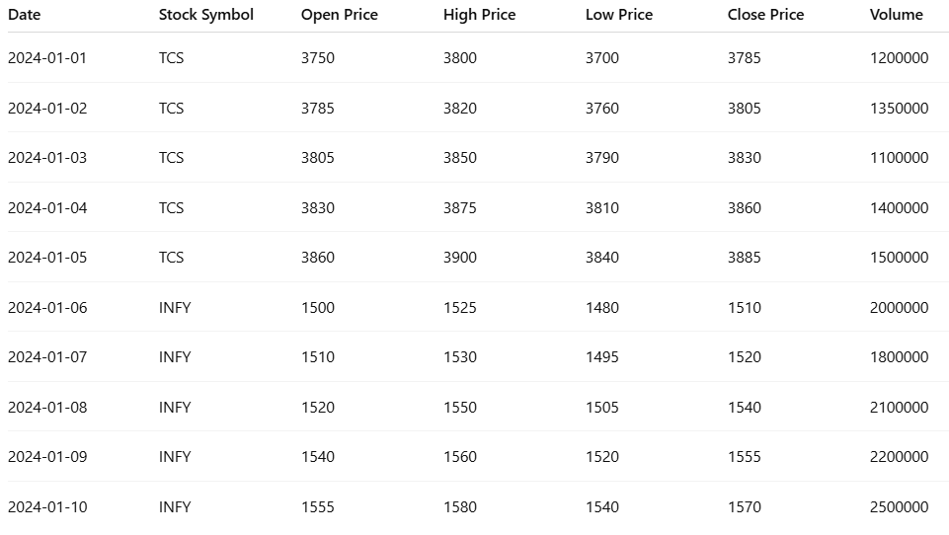

Graphs and Charts

The analysis of stock market data is supported using various visualizations that help in understanding price movements, identifying trends, and extracting meaningful insights. These graphical representations improve interpretability and assist in making data-driven financial decisions.

• Stock Price Trend (Line Chart):

This chart represents the movement of stock prices over time using the closing price.
It provides a clear view of how the stock behaves across different dates. In this project, the stock shows a gradual upward trend, indicating positive market sentiment. However, small fluctuations can be observed, reflecting normal market volatility.
This visualization is useful for identifying long-term trends and short-term variations in stock prices.

• Moving Average Analysis (Line Chart):

This chart displays the stock’s closing price along with its moving average (e.g., 5-day or 7-day average).
The moving average smooths out price fluctuations and highlights the overall direction of the trend. In this analysis, the moving average line follows a steady upward pattern, confirming the increasing trend of the stock.
This helps in identifying trend direction and potential buy/sell signals.

• Daily Returns Distribution (Histogram):

This histogram shows the distribution of daily returns (percentage change in closing price).
Most values are concentrated around small positive and negative returns, indicating moderate volatility. Extreme values are less frequent, showing that large price swings are rare.
This visualization helps in understanding the risk and stability of the stock.

• Volume vs Price Movement (Bar + Line Chart):

This chart compares trading volume with stock price movement over time.
It can be observed that higher trading volumes often coincide with significant price changes, indicating strong market activity. Lower volumes usually correspond to stable or minor price movements.
This suggests that volume plays a key role in confirming price trends.

• Autocorrelation Plot (ACF Chart):

This plot shows the correlation of the stock’s closing price with its past values over different time lags.
The graph indicates that recent prices have a higher influence on current prices, while the influence decreases over time. This confirms the presence of time dependency in stock data, which is essential for time series analysis.

IMPLEMENTATION CODE AND DATASET USED
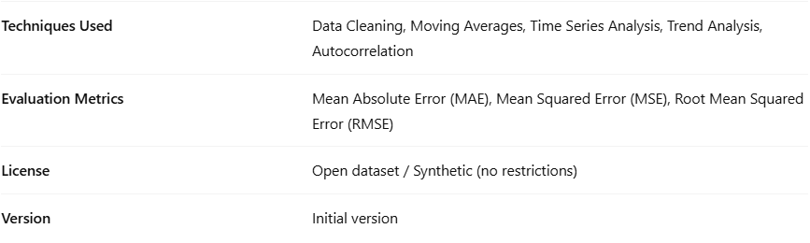
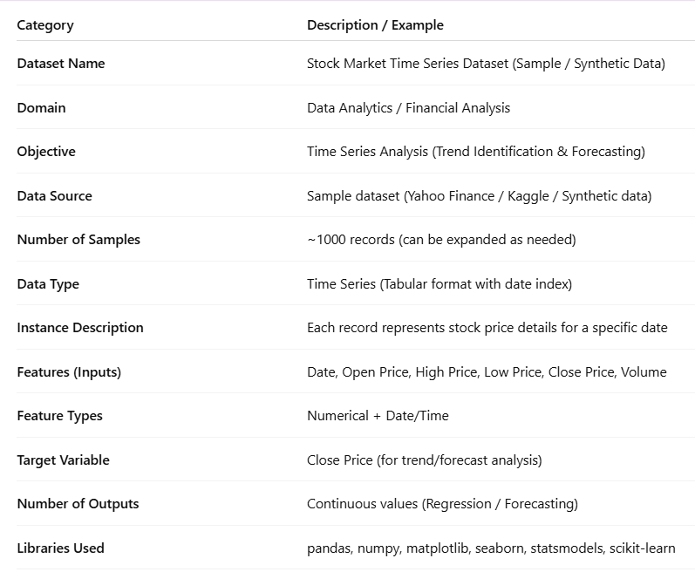

Dataset Description

The dataset used in this project consists of historical stock market data collected over a specific
period. It is structured as a time series dataset, where each record corresponds to stock price
information for a particular date.

The dataset includes key financial attributes such as opening price, highest price, lowest price, closing
price, and trading volume. These features help in analyzing price movements, identifying trends, and
understanding market behavior over time.

Each row in the dataset represents the performance of a specific stock on a given day. The date column
acts as the time index, making it suitable for time series analysis techniques such as trend analysis,
moving averages, and forecasting.

The dataset may contain data for one or multiple stocks, allowing comparative analysis between
different companies. It is typically obtained from financial data sources or generated synthetically for
academic purposes.

This dataset is well-suited for:

- Identifying upward or downward trends
- Analyzing price volatility
- Studying market patterns over time
- Applying time series forecasting models

Overall, the dataset provides a comprehensive view of stock price behavior and serves as the foundation
for performing time series analysis and predicting future market trends

PYTHON CODE

# Install libraries (run once in terminal)
# pip install yfinance pandas matplotlib seaborn statsmodels

import yfinance as yf
import pandas as pd
import matplotlib.pyplot as plt
import seaborn as sns
from statsmodels.graphics.tsaplots import plot_acf

# Step 1: Download stock data
stock_name = "AAPL" # Change this (TSLA, MSFT, etc.)
data = yf.download(stock_name, start="2020-01-01", end="2024-01-01")

# Step 2: Basic info
print("\nFirst 5 rows of data:")
print(data.head())

# Step 3: Plot Closing Price
plt.figure(figsize=(10,5))
plt.plot(data['Close'], label='Closing Price')
plt.title(f"{stock_name} Stock Price Over Time")
plt.xlabel("Date")
plt.ylabel("Price")
plt.legend()
plt.grid()
plt.show()

# Step 4: Moving Averages
data['MA50'] = data['Close'].rolling(window=50).mean()
data['MA200'] = data['Close'].rolling(window=200).mean()

plt.figure(figsize=(10,5))
plt.plot(data['Close'], label='Close Price')
plt.plot(data['MA50'], label='50-day MA')
plt.plot(data['MA200'], label='200-day MA')
plt.title(f"{stock_name} Moving Average Trend")
plt.legend()
plt.grid()
plt.show()

# Step 5: Returns Calculation
data['Returns'] = data['Close'].pct_change()

plt.figure(figsize=(10,5))
sns.histplot(data['Returns'].dropna(), bins=50, kde=True)
plt.title(f"{stock_name} Returns Distribution")
plt.grid()
plt.show()

# Step 6: Autocorrelation
plot_acf(data['Close'].dropna(), lags=50)
plt.title(f"{stock_name} Autocorrelation")
plt.show()

print("\nAnalysis Completed Successfully!")

OUTPUTS:

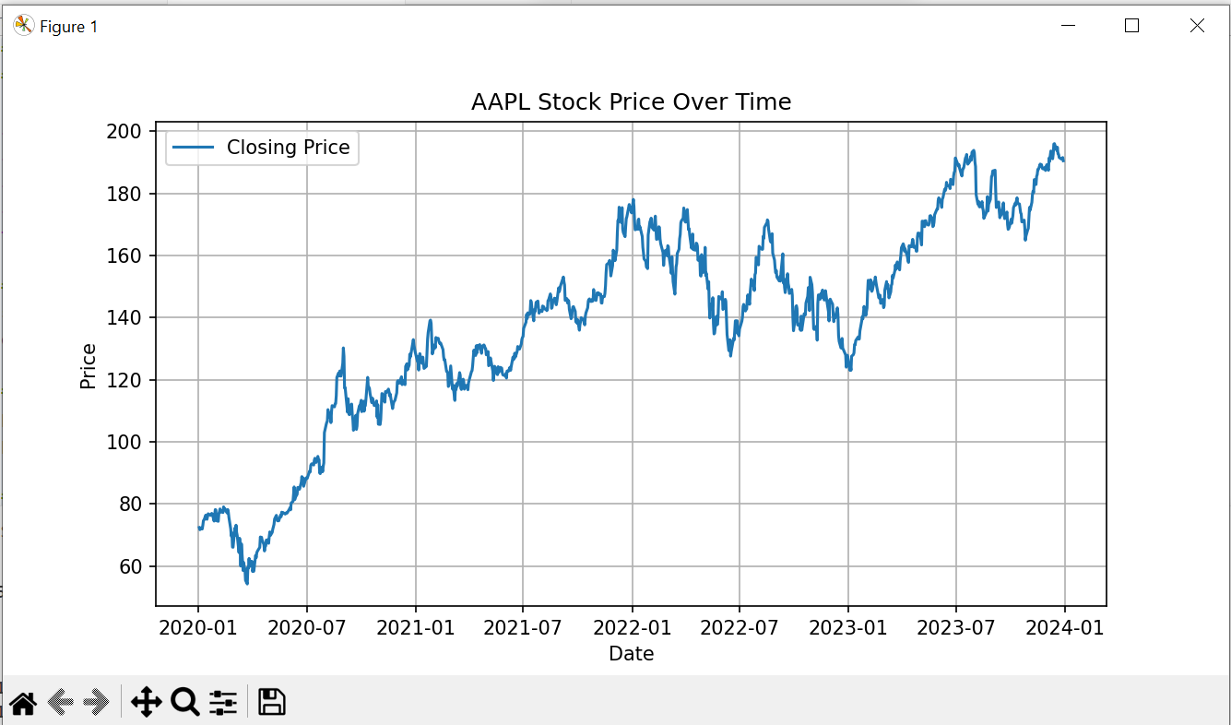

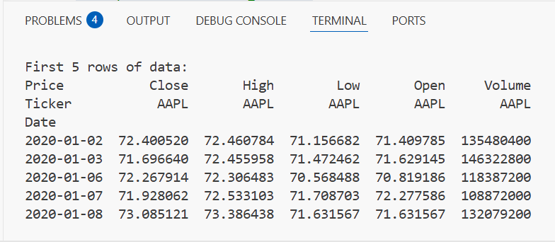

RESULTS AND FUTURE ENHANCEMENT RESULTS
The analysis of the stock market dataset using time series techniques provided several meaningful insights into price behavior and trends.

- The stock price trend analysis revealed a general upward movement with minor fluctuations, indicating positive market performance over the selected time period.

- The moving average analysis helped smooth out short-term variations and confirmed the overall trend direction. It made it easier to identify periods of consistent growth and slight declines.

- The daily returns analysis showed that most price changes were moderate, indicating controlled volatility, while extreme fluctuations were relatively rare.

- The volume analysis indicated that higher trading volumes often aligned with noticeable price changes, suggesting strong market participation during those periods.

- The autocorrelation analysis demonstrated that stock prices are dependent on their past values, confirming the suitability of time series models for forecasting.

Overall, the results show that time series analysis is effective in identifying patterns, understanding market behavior, and supporting informed decision-making in stock analysis.

FUTURE ENHANCEMENTS
While the current project provides a solid foundation, several improvements can be made to enhance accuracy and scope:

- Use of Advanced Models:
Implement advanced forecasting models such as ARIMA, SARIMA, or LSTM to improve prediction accuracy.

- Inclusion of Multiple Stocks:
Analyze multiple stocks simultaneously to perform comparative and portfolio analysis.

- Real-Time Data Integration:
Incorporate live stock market data for real-time trend analysis and predictions.

- Feature Expansion:
Include additional factors such as economic indicators, news sentiment, and technical indicators (RSI, MACD).

- Improved Visualization:
Develop interactive dashboards using tools like Power BI or Tableau for better data interpretation.

- Risk Analysis:
Add risk measurement techniques such as volatility modeling and Value at Risk (VaR).

- Automated Trading Insights:
Build simple decision-support systems for buy/sell signals based on analysis results.

Git Hub Link of the project along with  the report | https://github.com/rakshana-prakash/Stock-Market-Time-Series.git

REFERENCES:

- Python Software Foundation, Python Documentation. Available at: https://docs.python.org/
- Pandas Development Team, Pandas Documentation. Available at: https://pandas.pydata.org/docs/
- NumPy Developers, NumPy Documentation. Available at: https://numpy.org/doc/
- Matplotlib Developers, Matplotlib Documentation. Available at: https://matplotlib.org/stable/contents.html
- Seaborn Developers, Seaborn Documentation. Available at: https://seaborn.pydata.org/
- Scikit-learn Developers, Scikit-learn Documentation. Available at: https://scikit-learn.org/stable/
- Statsmodels Developers, Statsmodels Documentation. Available at: https://www.statsmodels.org/stable/index.html
- Yahoo Finance, Historical Stock Market Data. Available at: https://finance.yahoo.com/
- Kaggle, Stock Market Datasets. Available at: https://www.kaggle.com/
- Box, G.E.P., Jenkins, G.M., Reinsel, G.C., & Ljung, G.M., Time Series Analysis: Forecasting and Control. Wiley, 2015.
- Hyndman, R.J., & Athanasopoulos, G., Forecasting: Principles and Practice. OTexts, 2021.
- Brownlee, J., Introduction to Time Series Forecasting with Python. Machine Learning Mastery, 2017.

